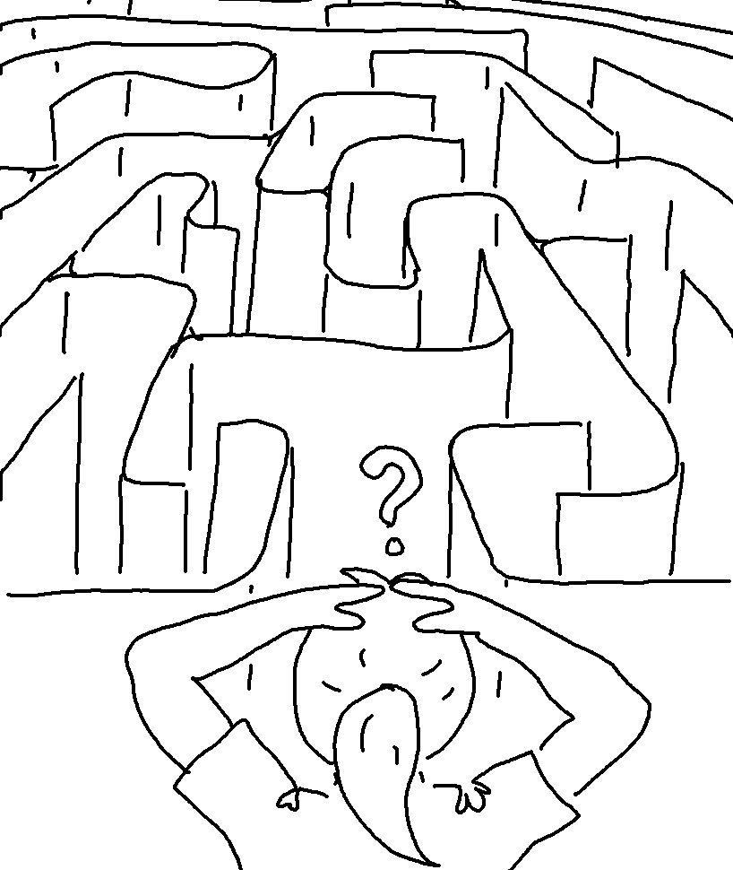
If you _ _ _ _ me, _ _ _ _ my _ _ _ _ _ _ _ _ _ _ _ _. John 14:15_{NLT}

